1. Backspace still working - fixed
2. Even if admin has activated account through manage users . application is not allowing user to login and it throws below msg- fixed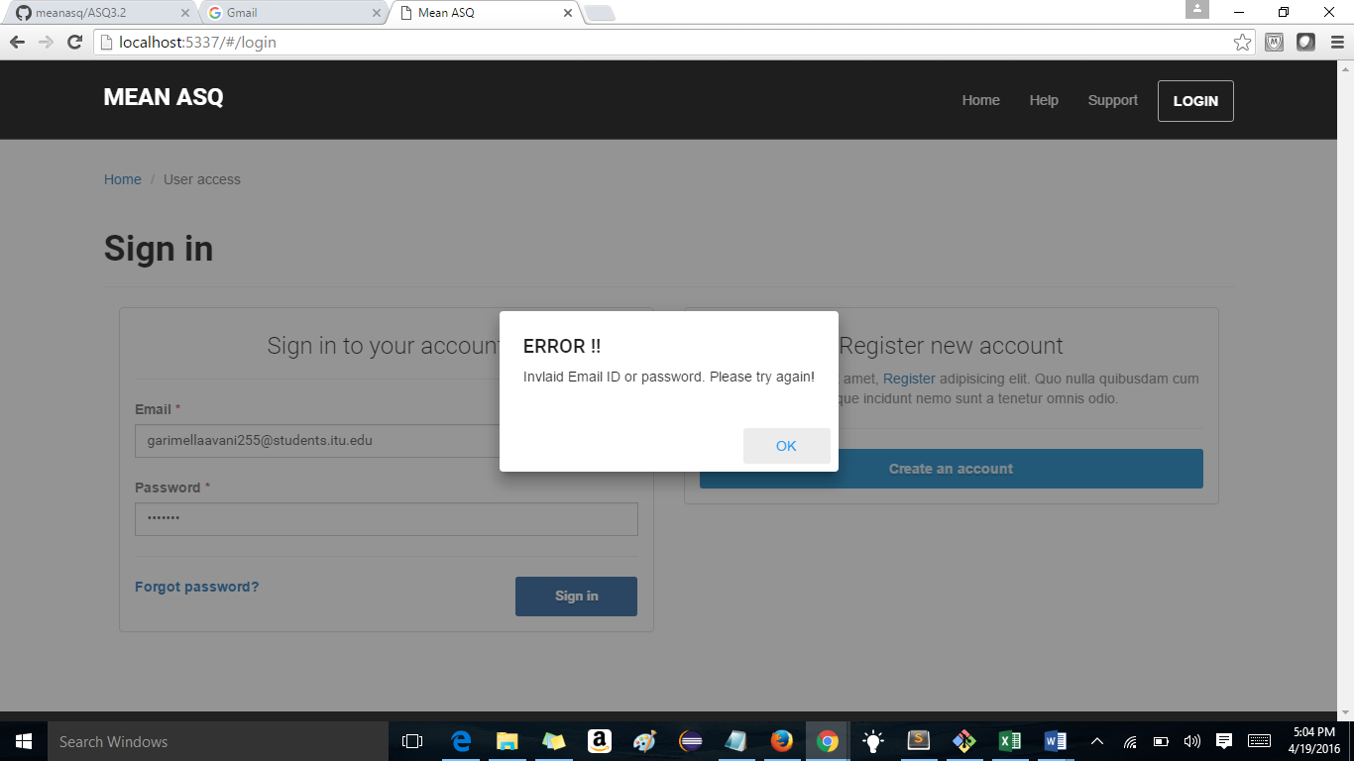
3. Activation error. Not activating the account throwing errors. The activation error message also not displayed properly that is it jus appears for a sec and success your logged out message pops up. So user cant read the activation error message also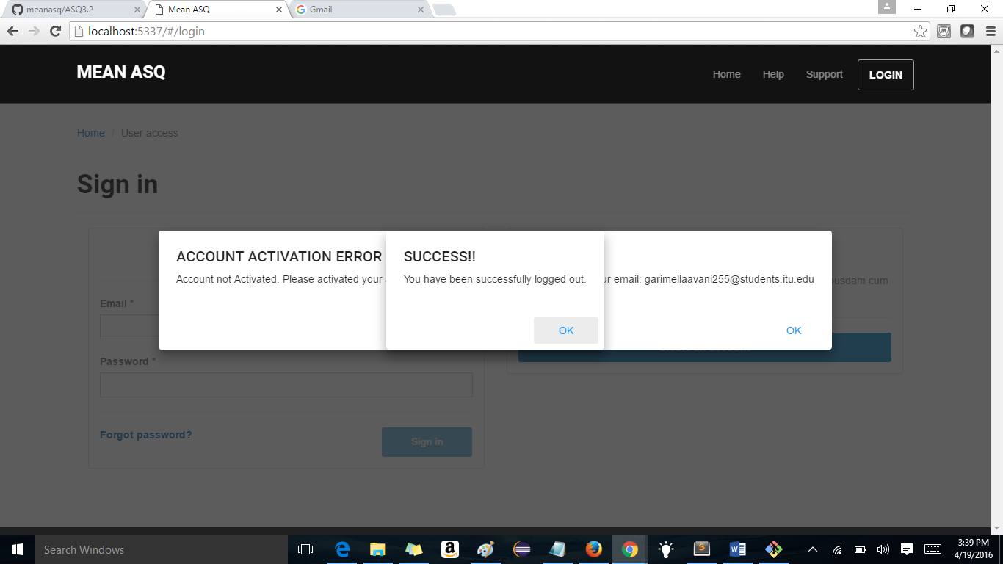
4. Clear form is clearing data but not error messages -fixed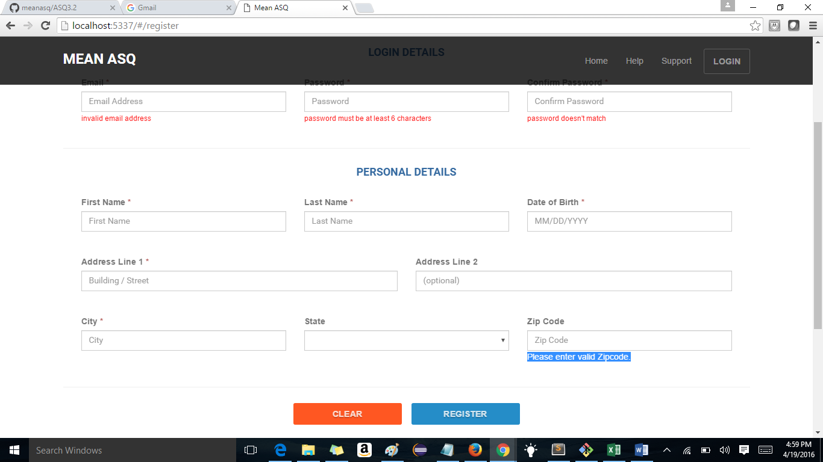
5. Password mis match and less number of characters in password is also allowed- fixed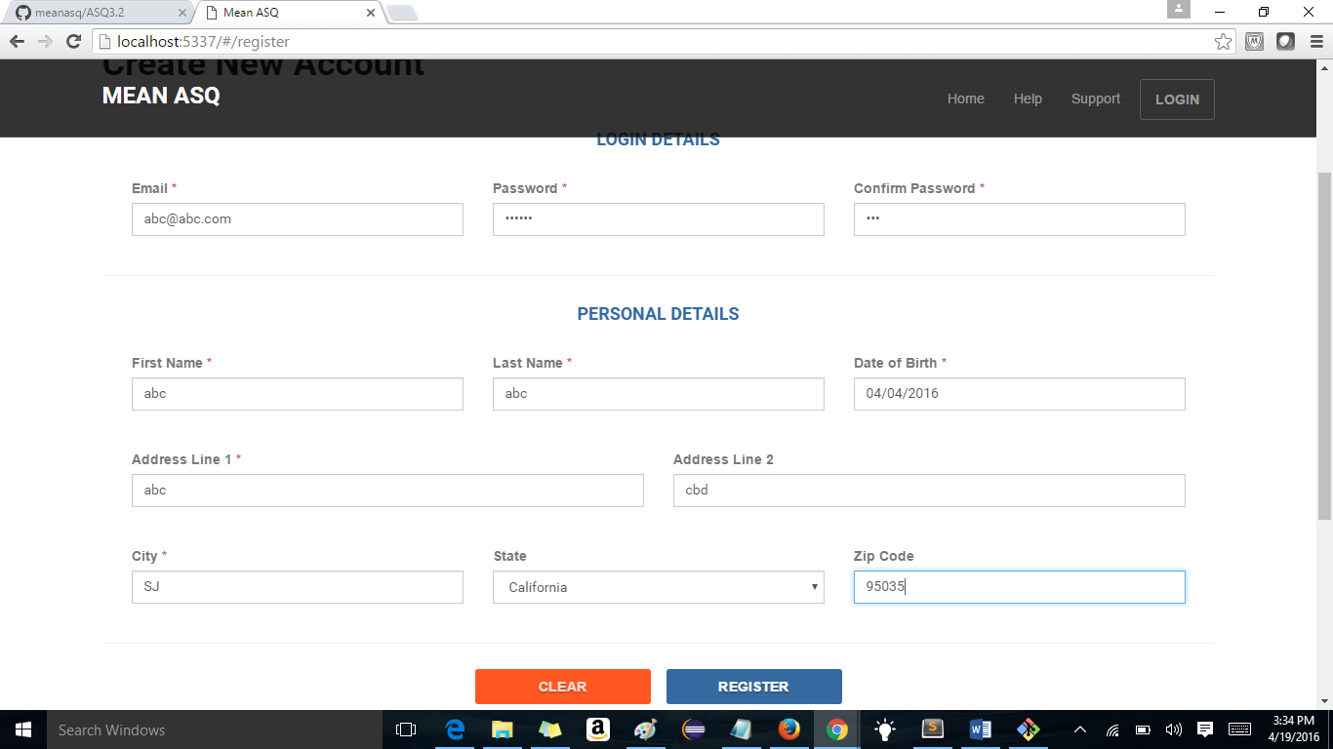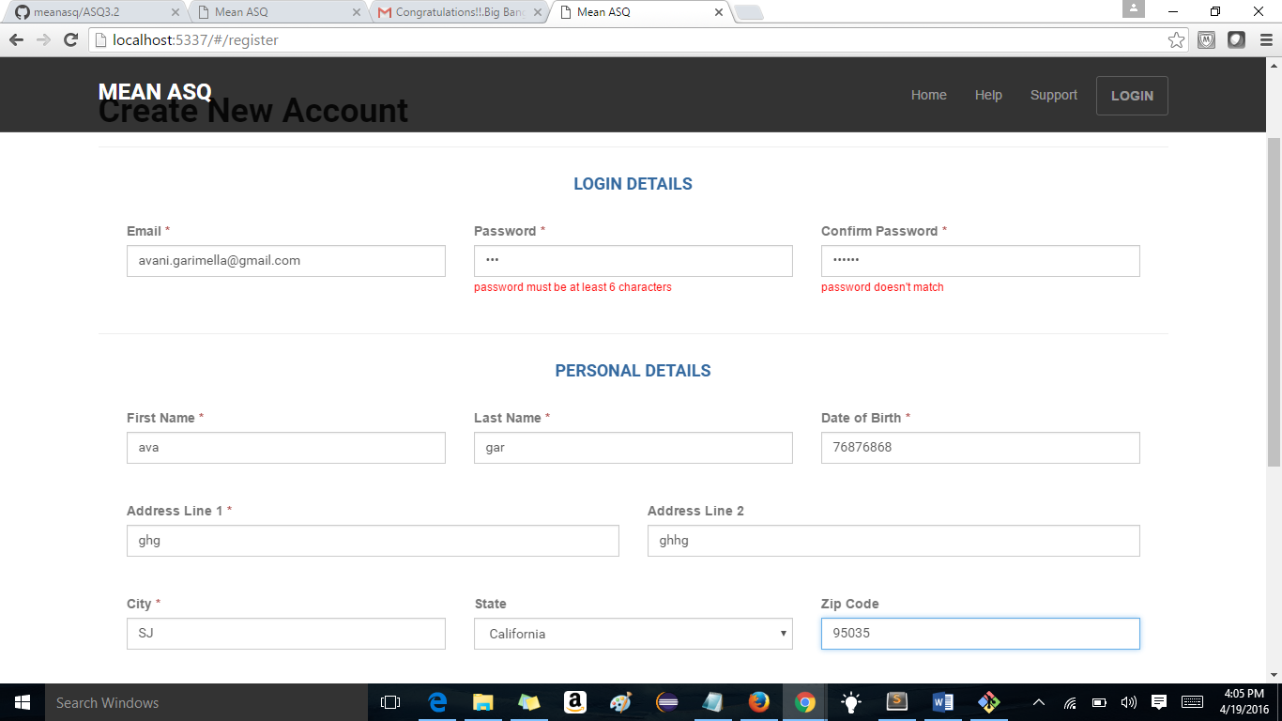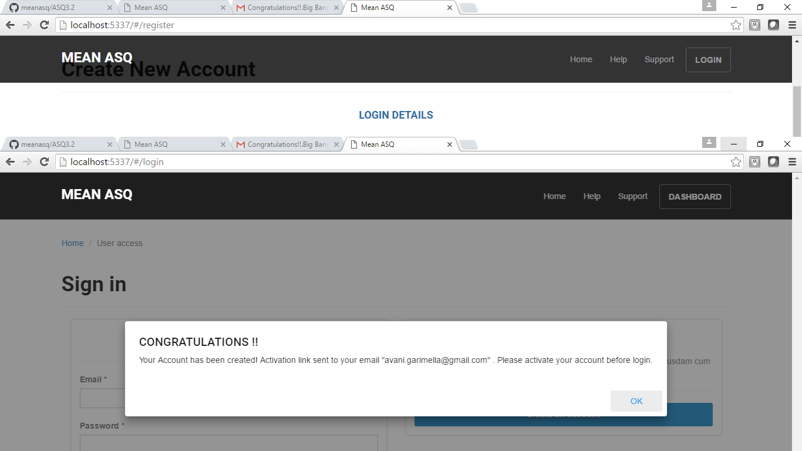
6. Zip code is not displayed as mandatory field so user gets confused when he clicks on register and it throws error message all reaquired fields need to filled. - fixed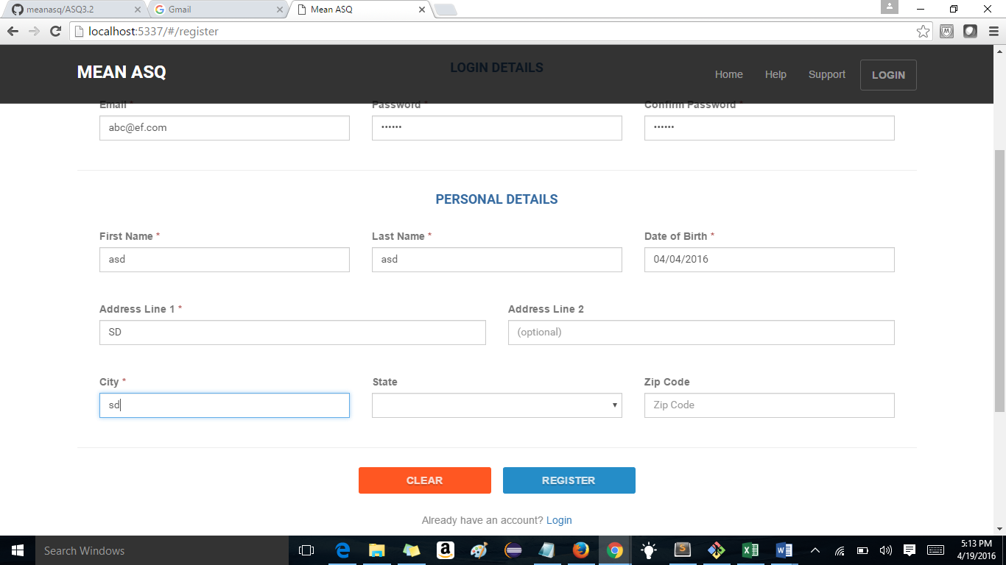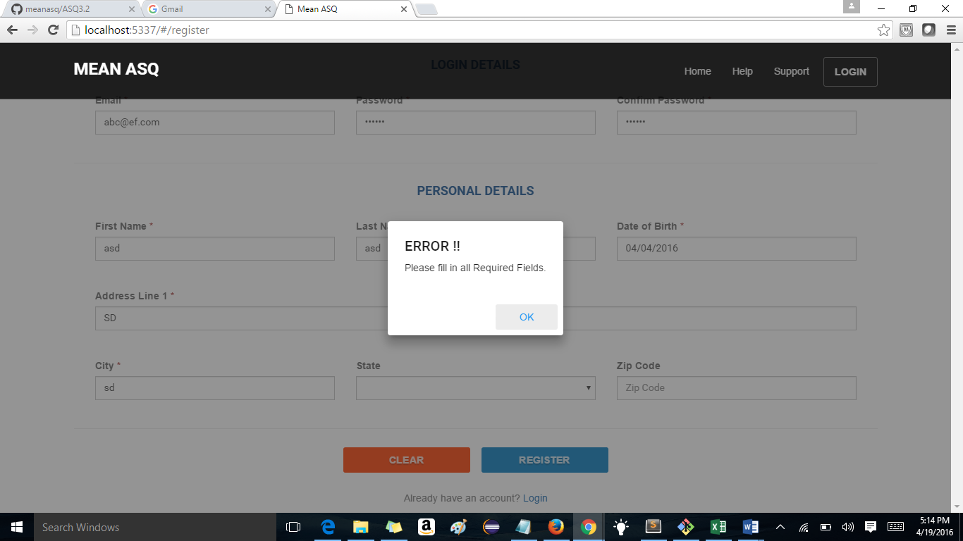
7. Date of birth field is taking range of numbers”876786678” and ten while clicking register changes that value to invalid date and registers the user-fixed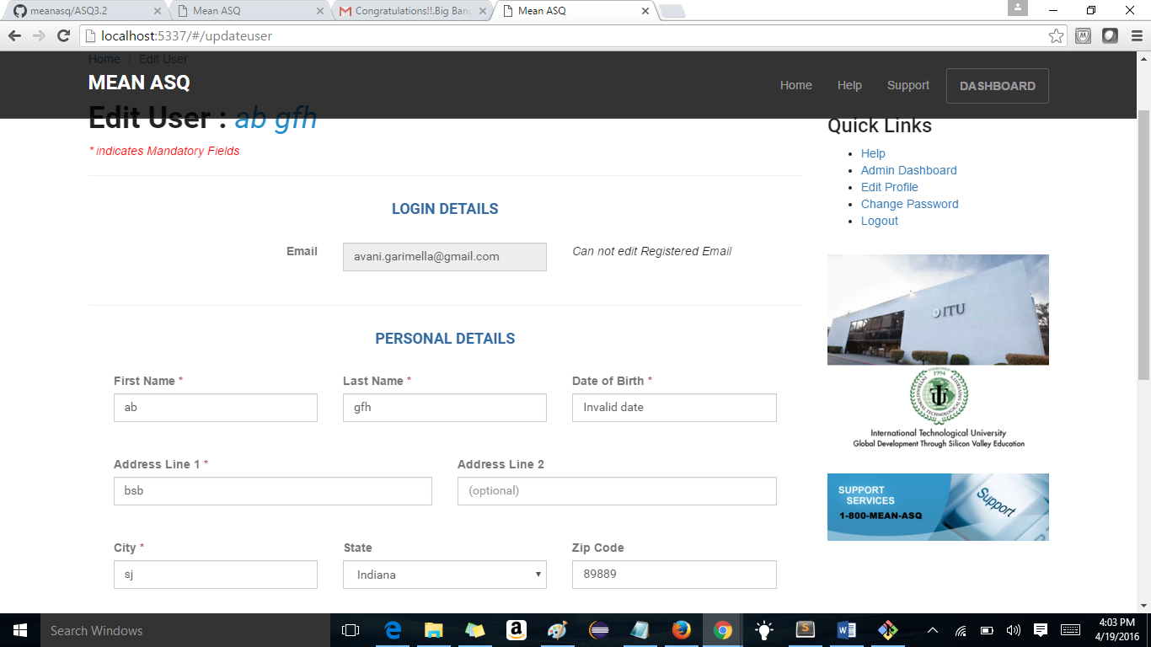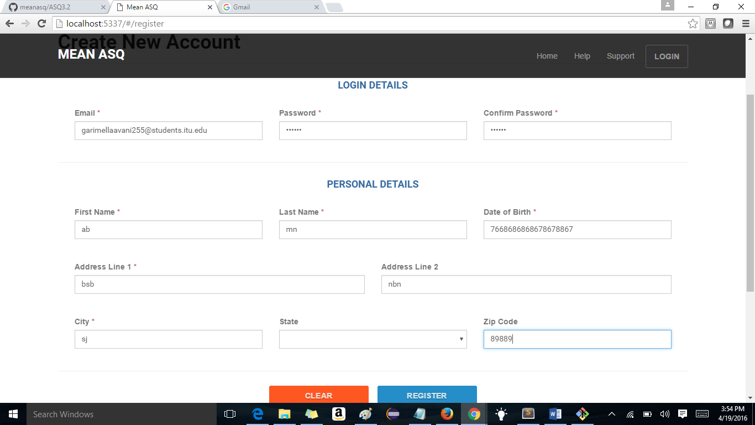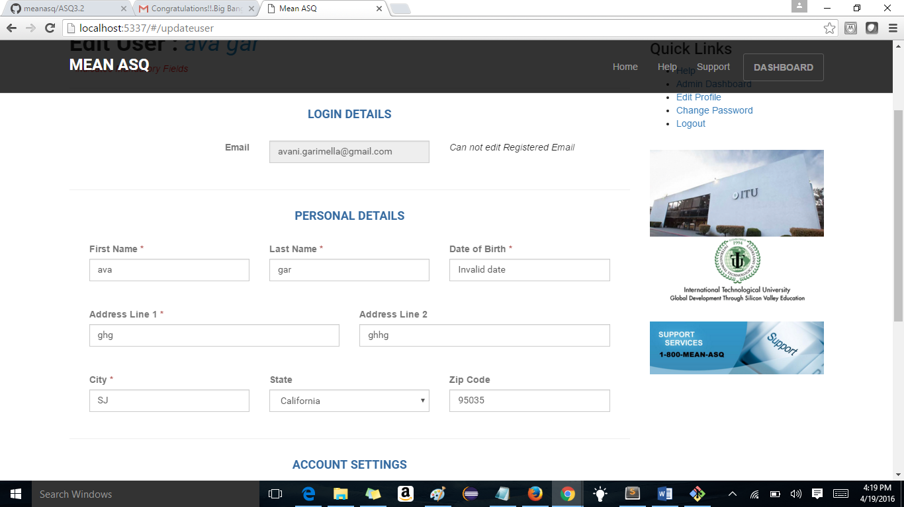
8. Invalid spelling is wrong - fixed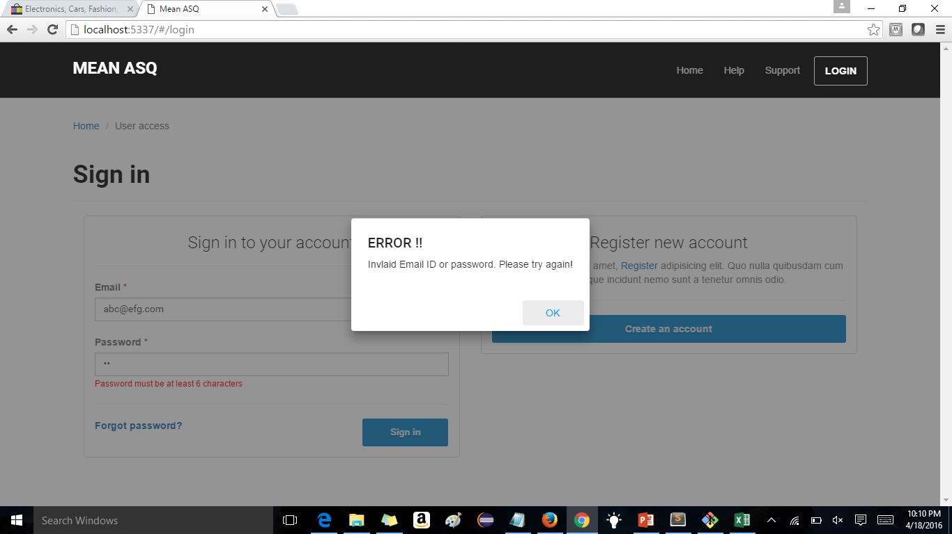
9. Expiry date field in manage users. – admin role. It shows date as 07/19/2016 but calendar is stuck at present date and if admin wants to chage the date to 06/19/2016 he cannot use calendar so he manually enters it and while doing so if enters date as919/2016 an clicks save – it saves the user and in the list it will be displayed as “invalid date” - fixed 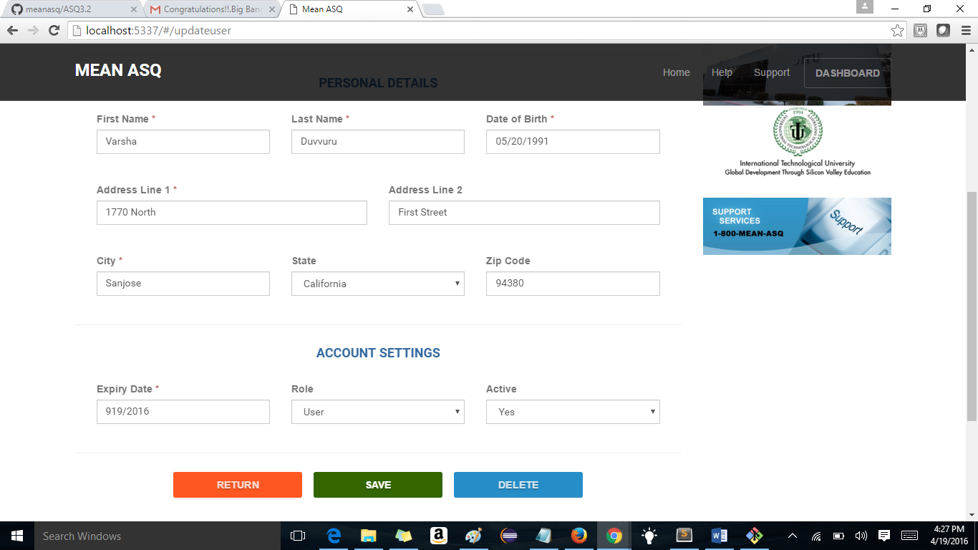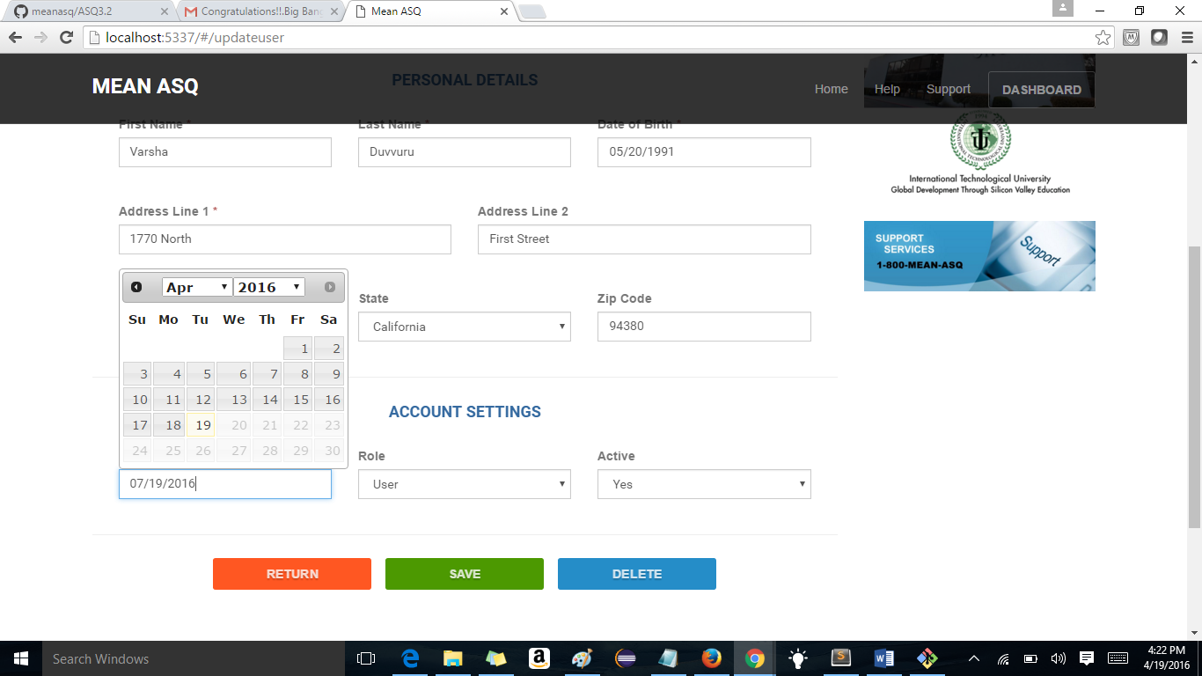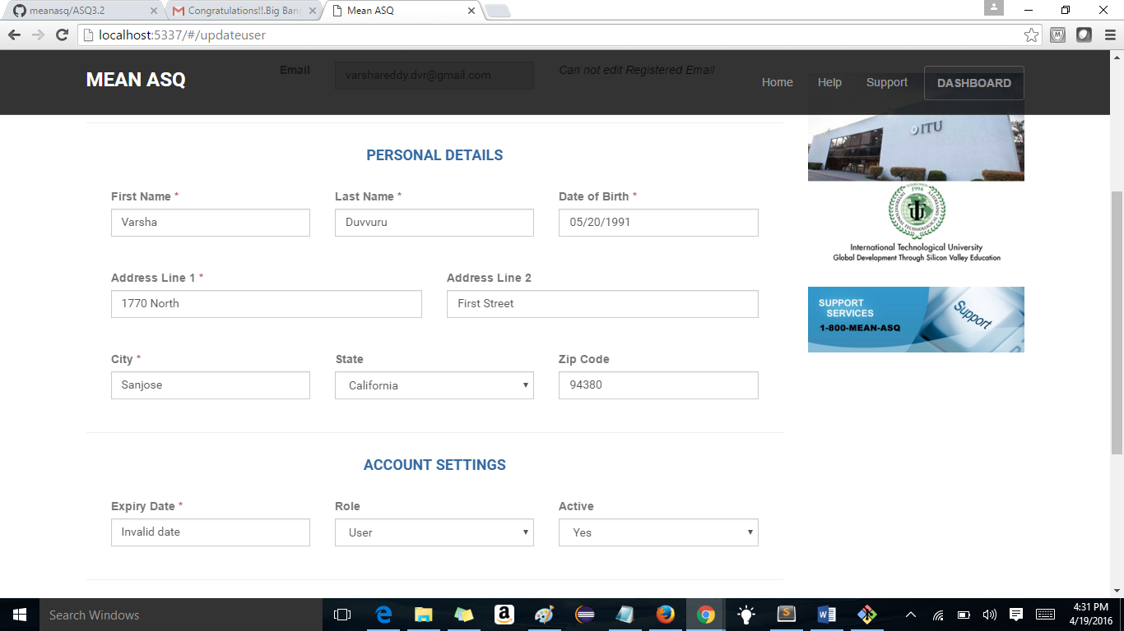
10. You registered successfully with an account and you want to register again so u click on register account button it throws the activation error and success logged out message and takes to home page and have to click on signup today or login to register new account - fixed

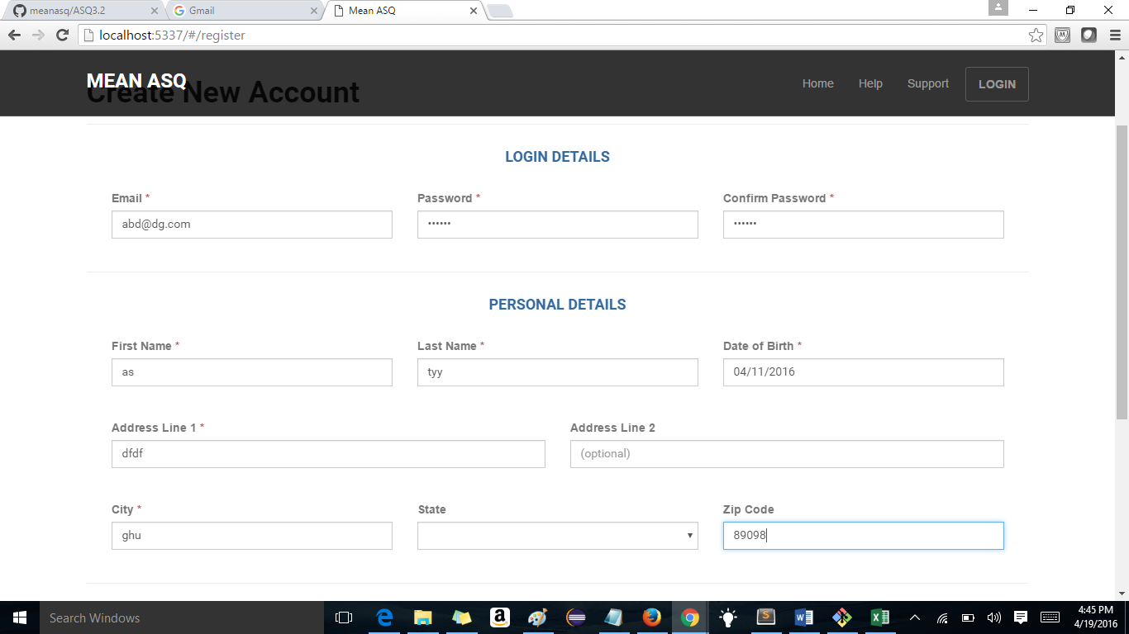

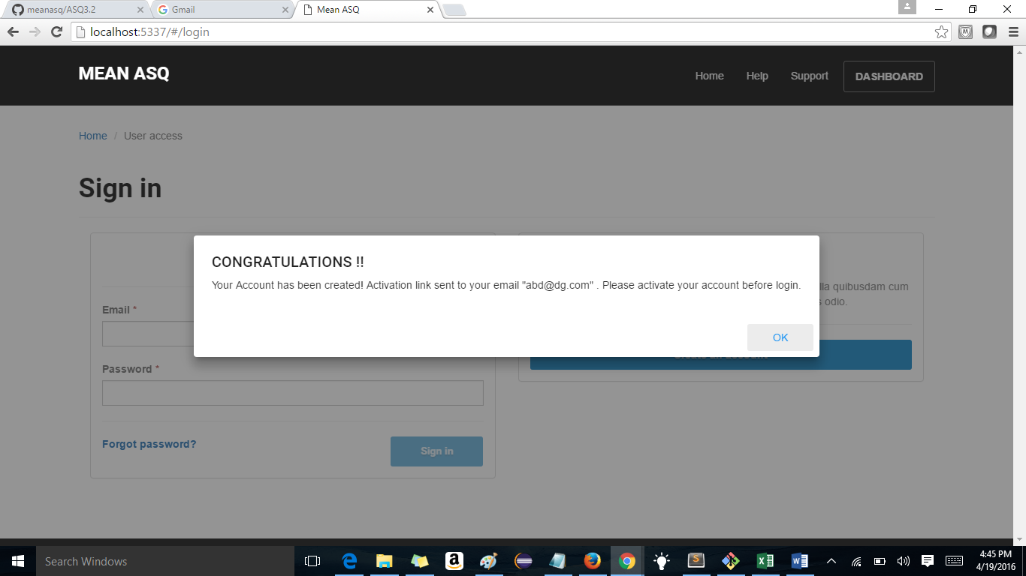

Registered and activation link is sent.And ten when I click om register account

The activation error and the success message below image is shown

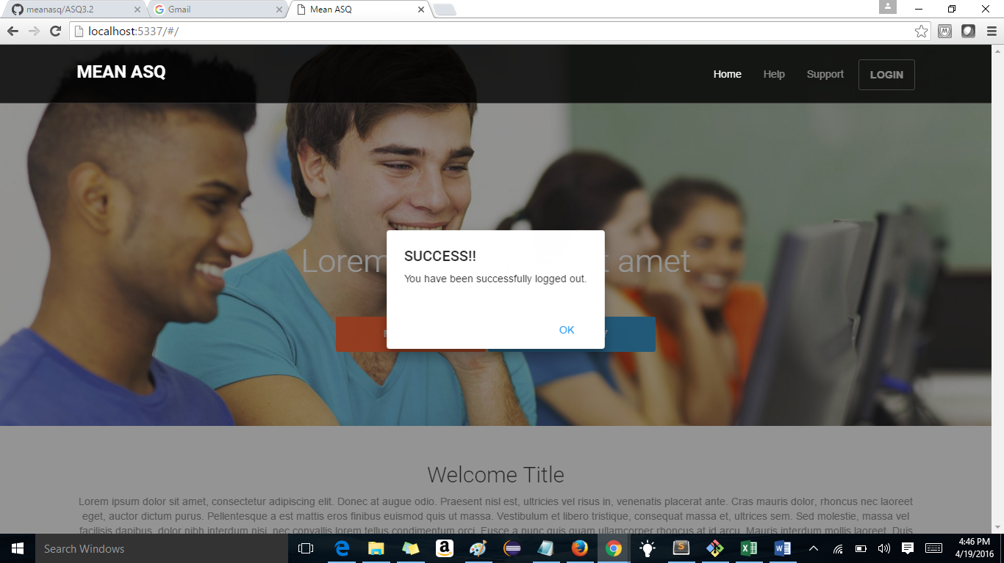

Ten again I have to hit signup or login to register again

